**MongoDB Quarries**

**Creating 3 Collection**: Database name is cscorner

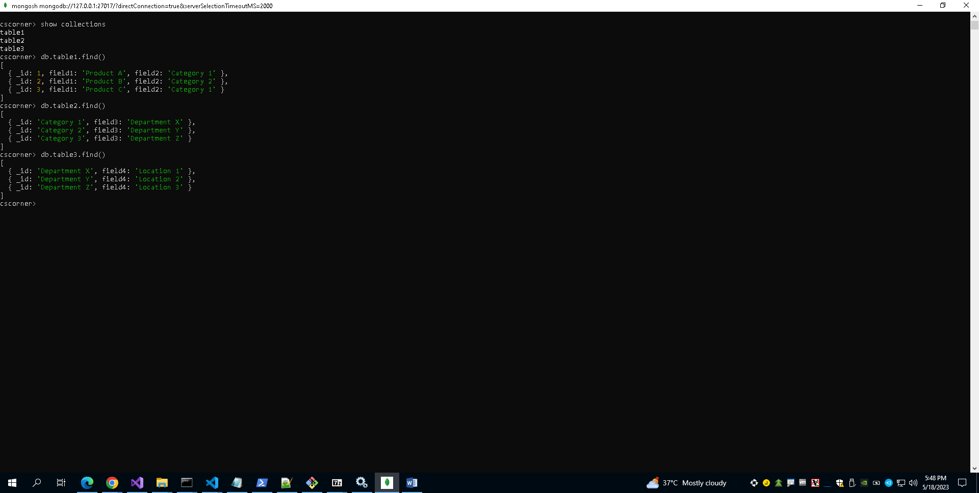

**Query a**: **A join of three or more tables – we should consider various types of join in this query (e.g. inner join, left/right/full outer joins, etc.) and the query must include a restriction on the rows selected**

**To join the three tables using different types of joins (inner join, left join, right join, and full outer join) in MongoDB, we'll use the aggregation framework. However, please note that MongoDB does not have native support for all types of joins. We can simulate the behavior of different join types using the aggregation pipeline**

1. **Inner Join**

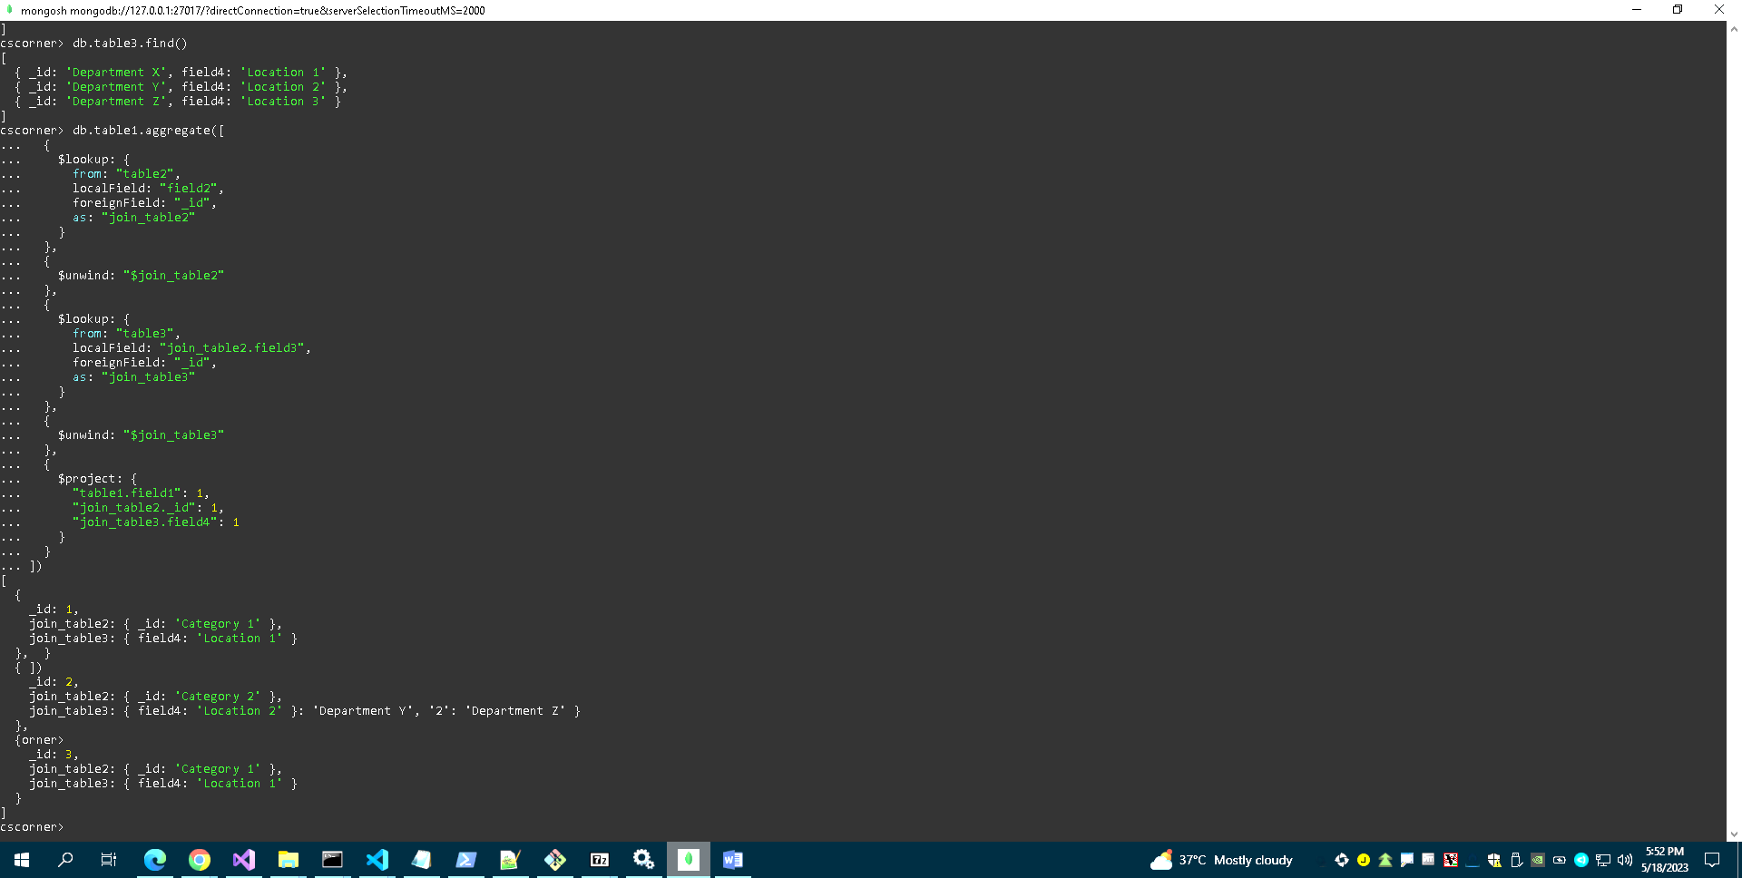

1. **Left Join:-**

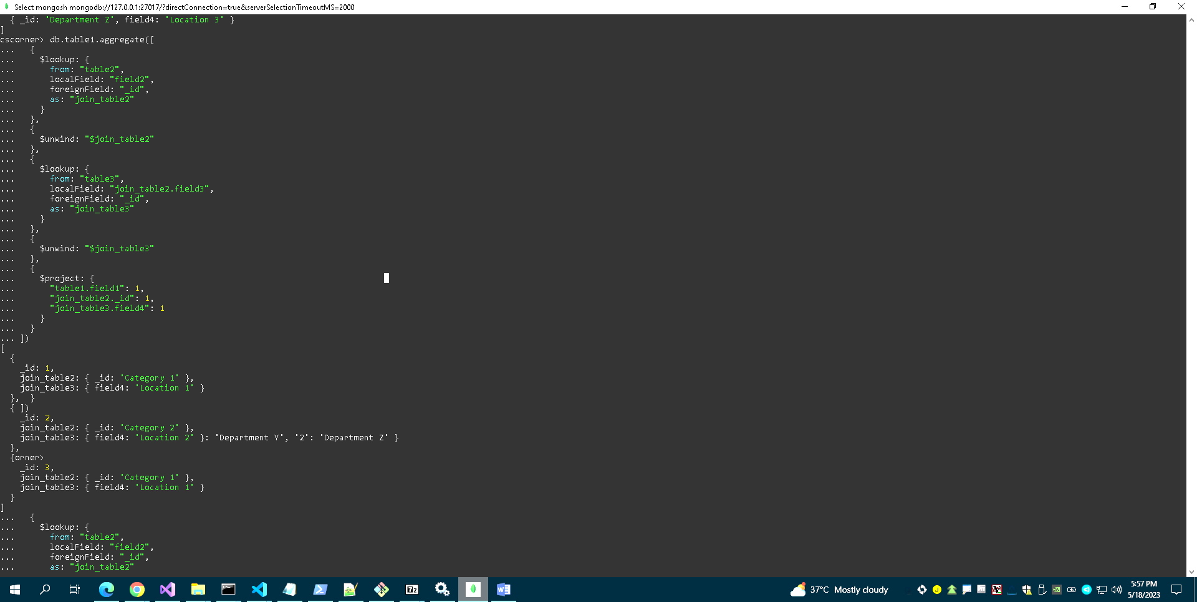

1. 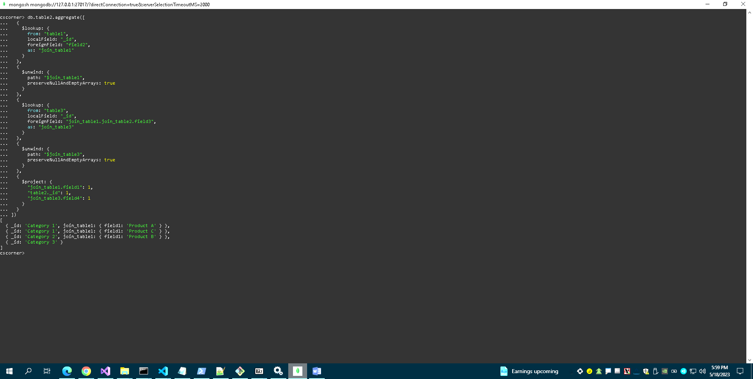**Right Join**
2. **Full Join**

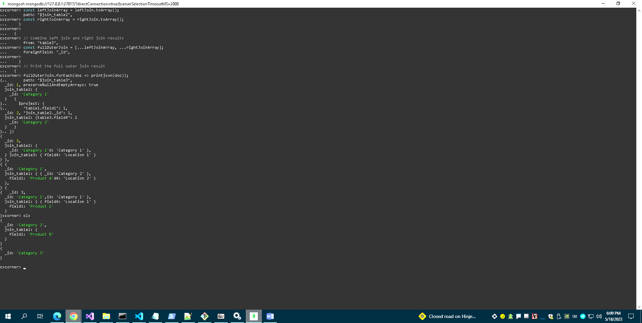**There is no native support for a full outer join. However, we can simulate a full outer join by combining the results of a left join and a right join.**

**Query B: - A query which uses one (or more) of the UNION, DIFFERENCE or INTERSECT operators**

**UNION Operation**

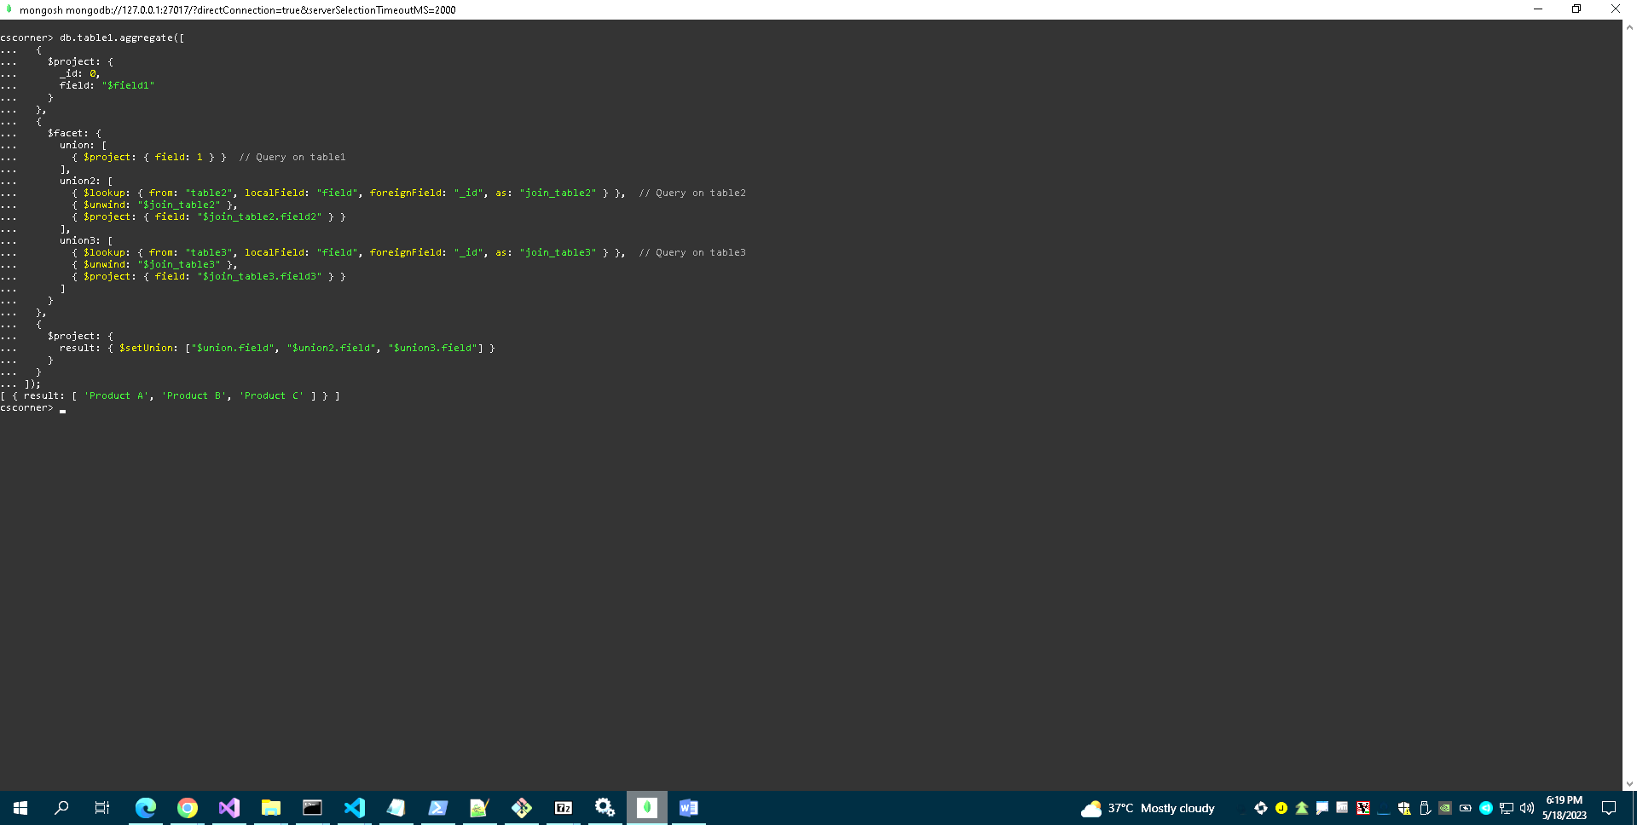

**INTERSECT Operation**

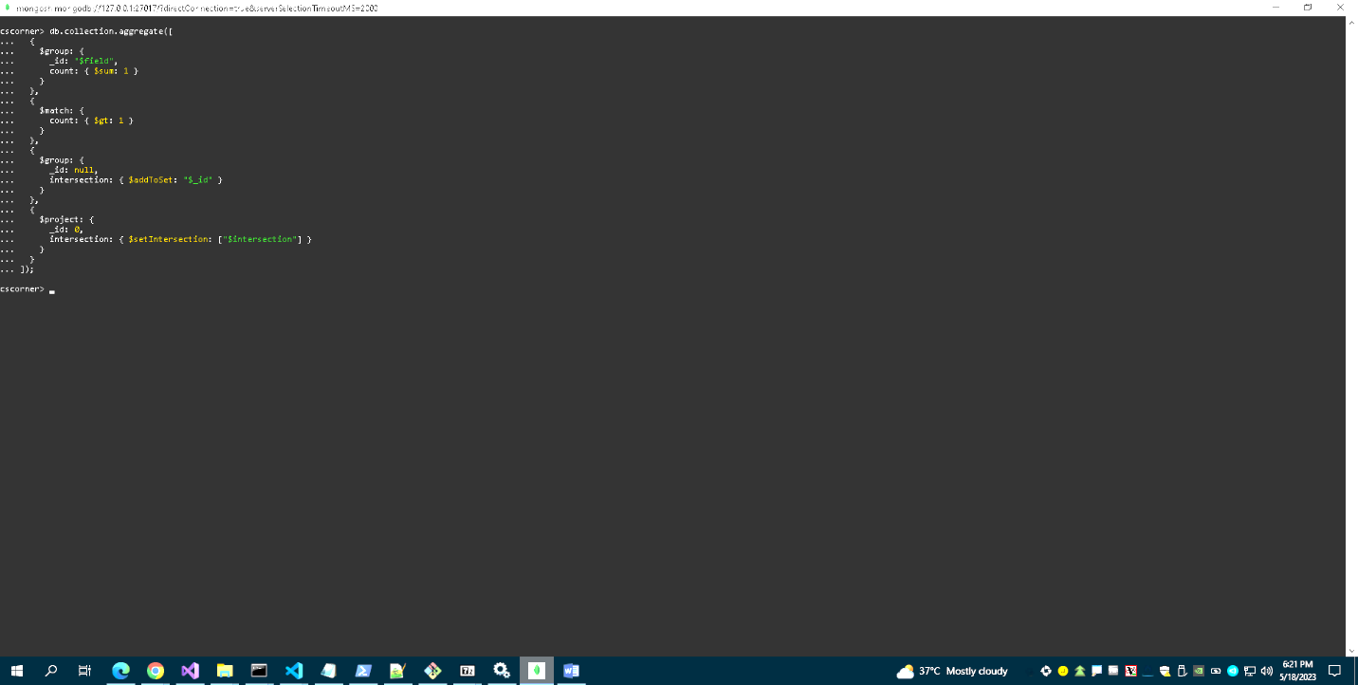

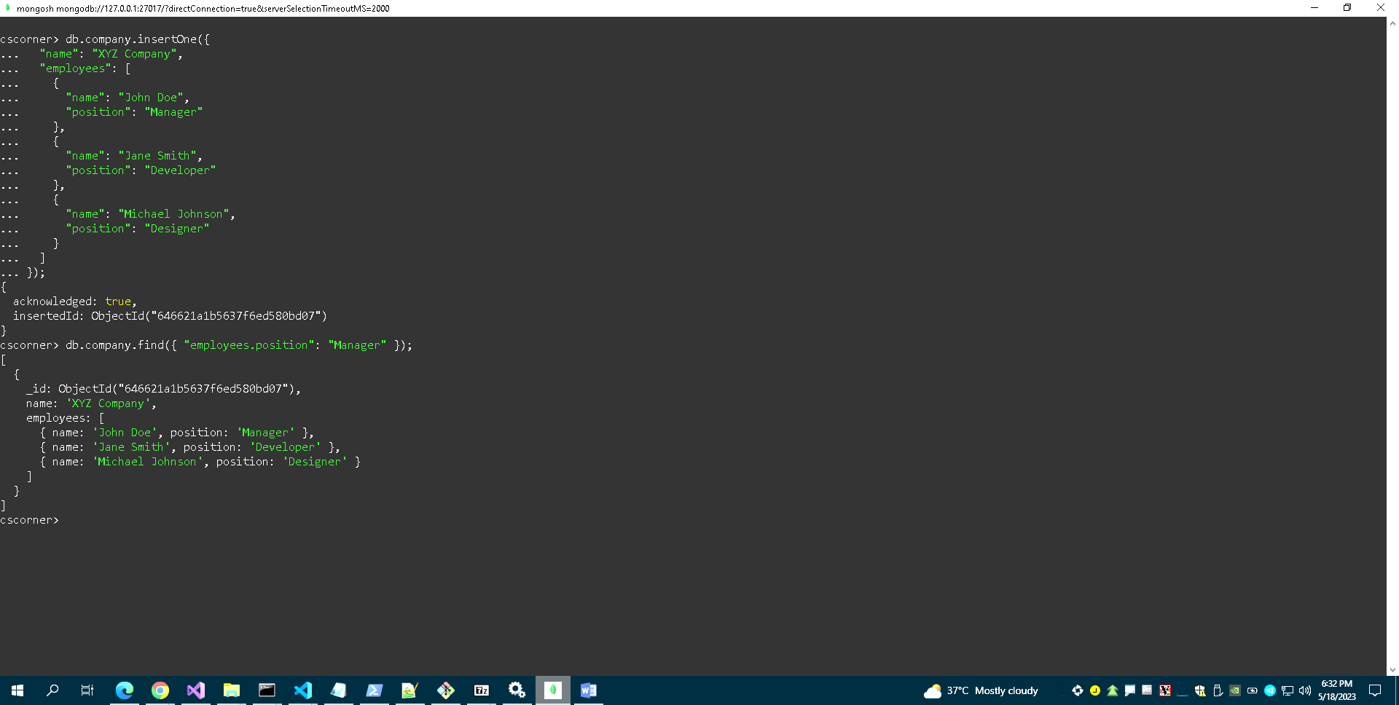**Query c:** **A query which requires use of either a nested table or subtypes**

**Query d**: **A query using temporal features (e.g., timestamps, intervals, etc.) of Oracle SQL**

**Timestamps:-**

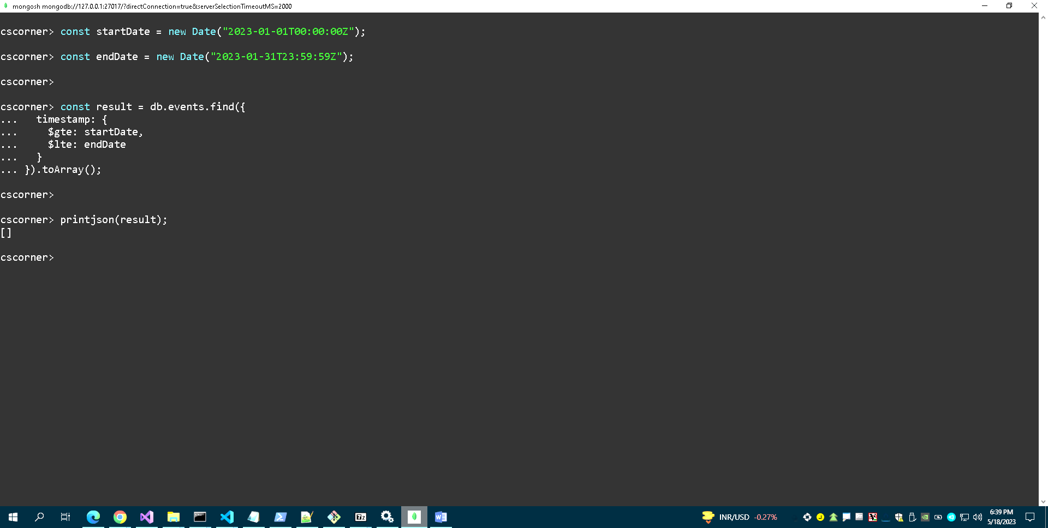

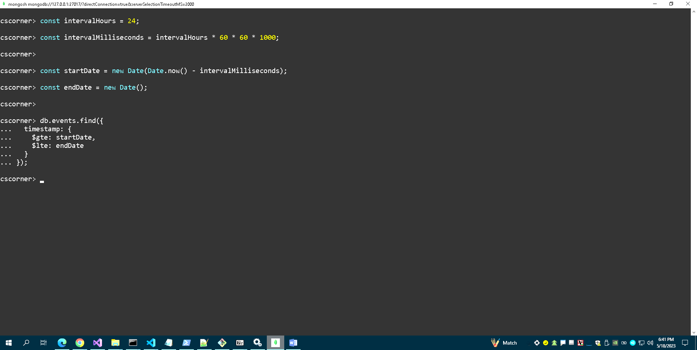**Interval:-**

**Query e:** **A query using OLAP (e.g., ROLLUP, CUBE, PARTITION) features of MongoDB**

MongoDB is a NoSQL document database that primarily focuses on online transaction processing (OLTP) rather than online analytical processing (OLAP) features. While MongoDB does not have built-in support for traditional OLAP features like ROLLUP, CUBE, or PARTITION, we can still achieve some similar functionality using MongoDB's aggregation framework.

The aggregation framework in MongoDB provides powerful aggregation and grouping capabilities that can be used for analytical purposes. Here's an example of how we can perform an OLAP-like query using the aggregation framework in MongoDB:

Assume we have a collection called "sales" that contains documents representing sales transactions with fields like "product", "category", "region", and "amount".

To perform a query that calculates the total sales amount by product and category, we can use the $group stage in the aggregation pipeline

